1. 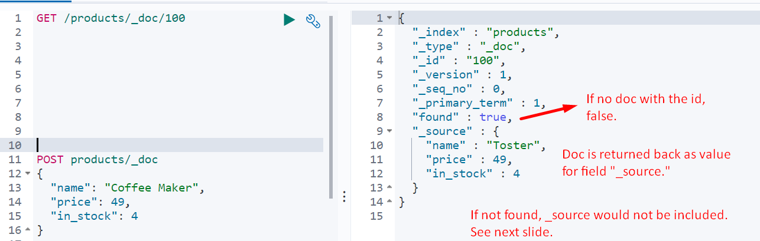
2. Case where doc with specified id doesn’t exist.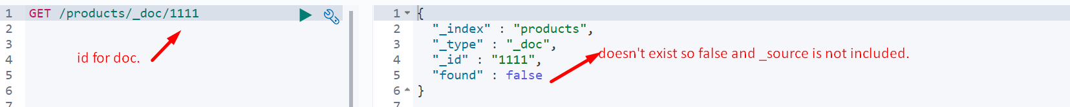
3. Later on, you will see how to perform searches for documents matching some criteria.